**Ideation Phase**

**Define the Problem Statements**

|  |  |
| --- | --- |
| Date | 2 November 2023 |
| Team ID | NM2023TMID05840 |
| Project Name | Creating Brand promo video |

**Customer Problem Statement Template:**

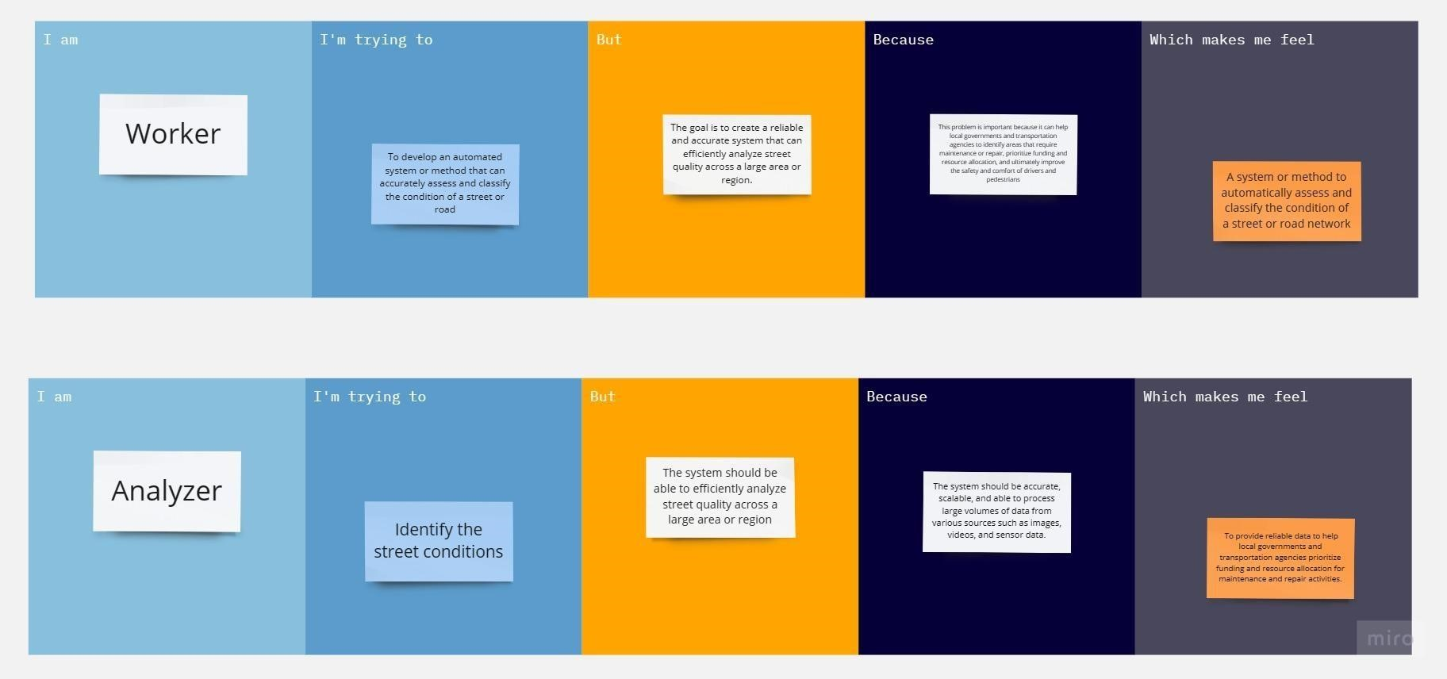

|  |  |  |  |  |  |
| --- | --- | --- | --- | --- | --- |
| **Problem**  **Statement (PS)** | **I am**  **(Customer)** | **I’m trying to** | **But** | **Because** | **Which makes me feel** |
| **PS-1** | **Worker** | Creating an Effective Brand Advertisement Using Canva: Explore the process of designing a visually compelling and persuasive brand advertisement using Canva, with a focus on capturing the attention of the target audience and conveying the brand's unique message and identity. | Designing a Brand Advertisement with Canva: A worker is faced with the challenge of creating a captivating and persuasive advertisement for their brand using Canva, aiming to effectively reach and engage their target audience while effectively showcasing the brand's identity and value. | Creating an Engaging Brand Advertisement with Canva: A worker is tasked with developing a compelling advertisement for their brand using Canva, because they need to effectively promote their products or services, capture the attention of their target audience, and convey the brand's unique value proposition in a visually appealing manner. | A worker embarks on the journey of crafting a captivating advertisement for their brand using Canva, which makes them feel both creatively empowered and strategically positioned to promote their products or services, engage their target audience, and effectively communicate the brand's unique value proposition. |
| **PS-2** | **Analyzer** | Identify the brand name. | Despite their analytical skills, the Analyzer faces the challenge of transforming data into visually appealing and effective Canva advertisements, striving to bridge the gap between data analysis and engaging design for brand promotion. | they recognize the importance of data-  driven marketing,  the Analyzer seeks  to utilize  their analytical  skills to create compelling brand advertisements  in  Canva that resonate with their target audience and  drive brand  success. | Create a visually engaging advertisement for our brand using Canva that evokes strong emotions and effectively communicates our brand message in a concise and compelling manner. |
|  |  |  |  |  |  |
|  |  |  |  |  |  |
|  |  |  |  |  |  |
|  |  |  |  |  |  |
|  |  |  |  |  |  |
|  |  |  |  |  |  |
|  |  |  |  |  |  |
|  |  |  |  |  |  |
|  |  |  |  |  |  |
|  |  |  |  |  |  |
|  |  |  |  |  |  |
|  |  |  |  |  |  |